Llynfi Dentals
Lapsed Patient Practice Policy

Did you know that to keep your NHS dental registration at our practice you need to attend regularly?
Many of our patients forget to make regular visits to see their dentist. And then, before they realise, it’s been nearly two years!
Due to the high number of people wishing to receive NHS dental treatment and the very long waiting lists, we have no choice but to de-active patients who have not attended for two years or more.
Why do we do this?
This allows us to make the most of the limited resources we have to provide NHS dental care.
How do I know what my recall frequency is?
Your recall frequency will be discussed at your most recent check-up and can vary from visit to visit depending on your dental need.
It is important that you make a note of this in your diary, to remind you to call us when you are next due. We try to remind our patients when they are due for their dental examinations via email and SMS. However, we often find that many of our communications get returned as patients do not update their details with us. Therefore, we expect you to check and update the correct contact details for yourselves on our system.
Please note, sending emails and SMS reminders is a complimentary service, and it is ultimately the patients’ responsibility to ensure that they remember their appointments and that we hold correct and current contact details for them. Falling lapsed, because we did not contact you is not a valid reason to be reinstated as an active patient in the Practice.
What to do to keep your registration?
Always attend any appointment booked or cancel the appointment more than 24 hours in advance and make sure to rebook.

Use it! Don’t lose it!
Once you have been de-activated, you are no longer able to receive NHS treatment at our practice. If you want to receive NHS treatment again, you will need to contact the Local Health Board and join the NHS Dental waiting list. This can be done either by following the link https://forms.office.com/r/uhnvEQFS8K . Or use the QR code below:
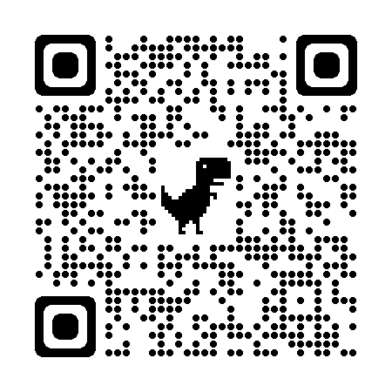
As NHS waiting lists are long, it may be some time before you can join another practice, therefore we highly recommend you look after your NHS appointments at our practice.

Check list for staying on the NHS active patients list:
- Attend all your appointments or cancel well in advance and rebook.
- Make sure your contact details are up to date with us (mobile and email). We don’t sent recalls via letter anymore.
- Make sure you visit your dentist regularly (and don’t leave it for longer than two years!)

PLEASE NOTE – If you have been removed from our active patients for a reason that is seen to be exceptional (examples include: aggressive behaviour to the team, bad debts, not turning up to booked appointments) then you will not be placed back onto our Active Patient lists.

*Please note, Lapsed NHS patients of the practice can still access NHS emergency care up until 4yrs after their last course of treatment, as per Welsh Government changes April 2022.

